Lab 1-1 ABC Background
Goals | Read the ABC document to become familiar with the business scenario for the fictitious company used throughout the course.
Time | 10 – 15 minutes
Environment | 
Instructions:
Read the following ABC document:
ABC

Business Scenario
ABC sells food and non-food items to restaurant chain customers throughout the United States. ABC is looking for a way to enable its current employees (especially experienced sales staff and operations managers) to ask their most pertinent business questions themselves. ABC believes that up-to-date sales performance monitoring, especially if it can be made exception-driven, will enable the company to better focus its management and customer service efforts. ABC also has the vision of making this data directly available to customers so they can better analyze their purchase history and compare it to what is being purchased nationally. ABC’s management feels that this added value will set them apart from their competitors and result in additional sales.
You are a consultant, hired by ABC to implement its business analysis. From your initial interviews with managers, you obtain the following information about ABC:
- Managers want use their own information to answer about the sales history of their products, the buying history of their customers, the order fulfillment performance of their operations group, and the selling performance of the sales force.
- The company has little experience in data analysis and they do not expect to hire any data analysts in the future. They want to be able to ask the relevant questions themselves without being required to learn more about computers.
- The database has about 350,000 invoice-level records (the “grain” of the database).
To make this kind of information widely available within the enterprise, it must have a structure consistent with the way employees think about the business.
From further interviews and examination of existing sample reports presenting invoice-based data, you determine the following:
- ABC employees think about their business in terms of sales, products and product hierarchies, time periods, and customer-sales force relationships.
- There are five levels of products. From the bottom (most detailed) level to the top, they are:
  - Specific Product
  - Generic Product
  - Sub-Type
  - Type
  - Total
- Many existing reports contain data presented at these levels. An example would be: (Product) Type = Cheese, (Product) Sub-Type = American Cheese, and Product = American Cheese Slices.
- There are five levels in the customer-sales organization. These levels mirror organizational management responsibilities. From the bottom, they are:
  - Customer
  - Sales Representative
  - District
  - Region
  - Total
- The time reporting periods are:
  - Day
  - Month
  - Year
  - Total time
In addition to these hierarchies, ABC would like to group customers using geographical attributes like Zip Code, City, and State. Likewise, they would like to analyze products by characteristics such as Diet Type and Suppliers.
The commonly reported measures are dollar sales, units ordered, units shipped, and net weight shipped. Another important measure for order fulfillment is “cuts,” the difference between the units ordered and units shipped (units ordered – units shipped). Operations management tracks this since cuts equals lost sales, and operations management is responsible for minimizing cuts.
ABC would like to look at all these measures at all levels of the hierarchy; by the important product and customer attributes, by the various time periods; and compare these with previous years.

Source Data
From interviewing the data administrators and examining documents they provide, you learn that the source data resides in the invoice system on a Microsoft SQL server. The data is at the invoice level.
In addition to the invoice information, there are various tables that provide information on customers, the product lines, the time periods, and the relationship between customers and the company’s sales organization.
It appears as though relevant data comes from the following tables, which exist in the invoice schema:

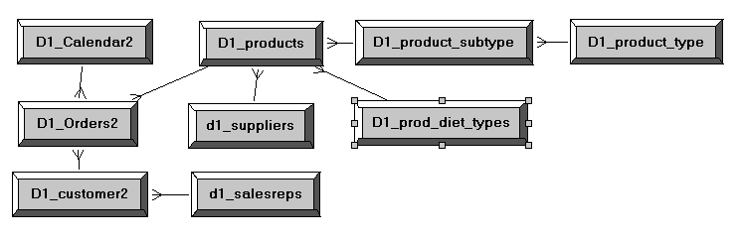
The following are examples of data in some of the tables.

D1_products
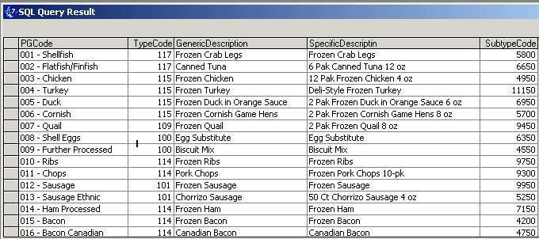

D1_product_type
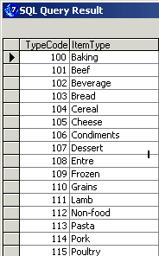

D1_product_subtype
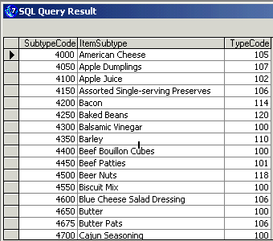

D1_customer2
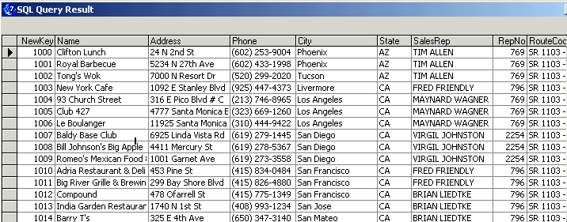

D1_Orders2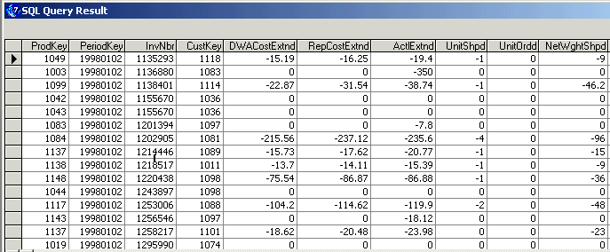

Lab 1-2 Gather Information to Start Building an Initial Business Model
Goals | To gather business data to design the business model.
Scenario | You are the server architect, and you need to build the business model. Following the recommended implementation methodology, gather information necessary to accomplish the tasks in the Define and Discover stages to develop the initial business model design.
Outcome | Some modeled data requirements.
Time | 10 – 15 minutes
Instructions:
Use the information in the ABC document to help you determine the following information, which you will need to implement the business model.
- What measures (facts) does ABC wish to report on?
- What hierarchies can you identify?
- Against which attributes (dimensions) does ABC want to analyze their facts?
- By which additional attributes does ABC want to analyze products?
- By which geographical attributes does ABC want to analyze data?
- Complete the following diagram with your identified facts and dimensions:

(Facts)
(Dimension)
(Dimension)
(Dimension)

Solutions 1-2 Gather Information to Start Building an Initial Business Model
Answers
1. What measures (facts) does ABC wish to report on?
Dollar sales, Units Ordered, Units Shipped, Net Weight Shipped, Cuts
2. What hierarchies can you identify?
Product, Time (Period), Customer/Sales Rep
3. Against which attributes (dimensions) does ABC want to analyze their facts?
Product, Time (Period), Customer
4. By which additional attributes does ABC want to analyze products?
Supplier, Diet Type
5. By which geographical attributes does ABC want to analyze data?
Zip Code, City, State
6. Complete the following diagram with your identified facts and dimensions:
Sales
Time Period
Customer
Product

Lab 1-3 Verifying and Testing a Data Source
Goals | To verify connectivity to an Open Database Connectivity (ODBC) Data Source and test it using the Analytics Client.
Scenario | ABC has just finished designing the business model, and the team has identified that the physical data to support the business model resides in a Microsoft SQL Server supplier2 database. You will first verify the connection to the supplier2 database using the ODBC Data Sources Administrator in order to import the schemas into the repository, and then test the connectivity using the Analytics ODBC Client.
Outcome | Verified ABC ODBC data source connectivity.
Time | 5 – 10 minutes
Instructions:
- As the server architect, verify your connectivity to the supplier2 database in MS SQL Server.
  - Select Start > Programs > Administrative Tools > Data Sources (ODBC).
  - Select the System DSN tab.
  - Select the ABC data source.
  - Click Configure.
  - Observe that the name of the data source is ABC, and the SQL Server you want to connect to is on your local machine (localhost).
  - Click Next.
  - Verify authentication.
    - Verify that the With SQL Server authentication… radio button is selected.
    - Verify that the Connect to SQL Server to obtain default settings…check box is selected.
    - Verify that sa is in the Login ID field and the Password field is blank.
    - Click Next.
  - Verify the default data source.
    - The Change the default database to is set to supplier2.
    - Click Next.
  - Click Finish. A list of the configuration options you selected displays.
  - Test that the data source connection is valid.
    - Click Test Data Source and verify that you get the message “…TESTS COMPLETED SUCCESSFULLY!”
    - Click OK.
    - Click OK again.
    - Click OK to close the ODBC Data Source Administrator.
- Test the connection to the ABC ODBC data source using the Siebel Analytics ODBC Client tool.
Note: Siebel Analytics ODBC Client Tool is an administrator tool that provides an environment for testing connectivity to physical data sources. However, this can be accomplished using any ODBC-compliant tool.
  - Select Start > Programs > Siebel Analytics > Siebel Analytics ODBC Client.
  - Select File > Open Database.
  - In the DSN field, use the drop-down list to select ABC.
  - In the UID (user ID) field, type sa (no password).
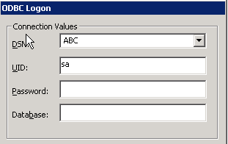
  - Click OK.
- Now that you have connected successfully to the ABC data source, view the schema for supplier2.
  - Select Utility > View Schema.
  - In the Database Tables field, select the D1_Calendar2 table. What happens?
  - In the Columns in the Current Table field, scroll down to select the Month_in_Year column. What happens?
  - Review the attributes of the Month_in_Year column.
    - What is the column Type?
    - Is this a required column?
  - Close the Database Schema window.
- Use the schema information just gathered to issue a query directly to the supplier2 database.
  - Select Utility > Enter SQL Query.
  - Create a query to request the number of distinct months in a year. In the SQL Statement Editor, type the SQL statement SELECT distinct month_in_year FROM d1_calendar2.
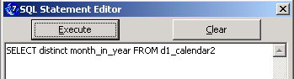

  - Click Execute. Check your results:
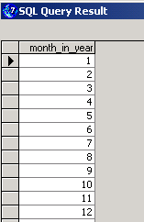
Note: Executing the SQL and generating the results above proves that you have connected to the supplier2 database schema successfully through your ABC ODBC data source.
- Select File > Exit to exit the Siebel Analytics ODBC Client.

Solutions 1-3 Verifying and Testing a Data Source
Answers
3.b. In the Database Tables field, select the D1_Calendar2 table. What happens?
The columns in this table display in the Columns in the Current Table field.
3.c. In the Columns in the Current Table field, scroll down to select the Month_in_Year column. What happens?
The attributes of this column display in the attributes of the Current field.
3.d.i. What is the column Type?
A small integer, or SMALLINT
3.d.ii. Is this a required column?
No
Lab 1-4 Importing a Data Source
Goals | To create a new repository and import the table schemas from an external data source.
Scenario | You verified the connection to ABC’s supplier2 database by testing your connectivity using the Analytics ODBC Client. Now, you are ready to create a new repository and import the supplier2 schema into the Physical layer of the repository using the Administration Tool.
Outcome | New ABC.rpd file containing D1_Calendar2, D1_customer2, D1_Orders2, and D1_products tables in the Physical layer.
Time | 10 – 15 minutes
Instructions:
Before you import the table schema into the Physical layer of the repository, examine the tables and keys defined in the supplier2 MS SQL database, using MS SQL Server Administration utilities.
- Select Start > Programs > Microsoft SQL Server > Enterprise Manager.
- Examine the supplier2 database table object.
  - Expand Microsoft SQL Servers.
  - Expand SQL Server Group.
  - Expand (local) (Windows NT).
  - Expand Databases.
  - Expand supplier2.
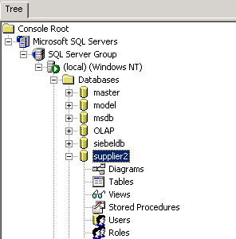
- Examine the properties of the D1_Calendar2 table in the supplier2 database.
  - Click the Tables icon.
  - In the right pane, double-click the D1_Calendar2 table. The Table Properties dialog box appears:
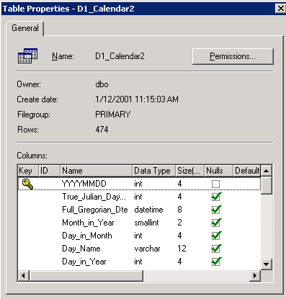
  - What column is the primary key constraint defined on?
  - How many rows are in this table?
  - Scroll down and examine the table columns.
  - Click Cancel to close the Table Properties window.
- Examine the properties of D1_customer2 table in the supplier2 database.
  - In the right pane, double-click the D1_customer2 table. The Table Properties dialog box appears:
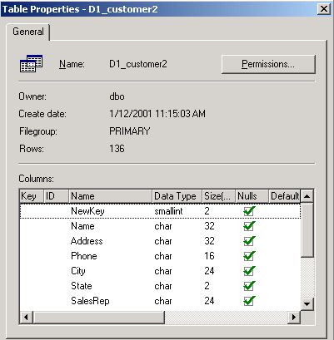
  - Is there a primary key constraint defined on this table?
  - How many rows are in this table?
  - Scroll down and examine the table columns.
  - Click Cancel to close the Table Properties window.
- Repeat this process for the following tables, answering the questions below for each table you examine:
Table Name
D1_Orders2
D1_products
  - Is there a primary key constraint defined on D1_Orders2?
  - Is there a primary key constraint defined on D1_products?
  - Click Cancel to close the Table Properties window.
  - Select Console > Exit to close Enterprise Manager.
- Create a new repository file for ABC.
  - Select Start > Programs > Siebel Analytics > Siebel Analytics Administration.
  - Select File > New.
  - To name the repository, enter ABC in the File name field and click Save.
- Import ABC’s table schemas from the supplier2 database.
  - Select File > Import > from Database.
  - Scroll down to select ABC:
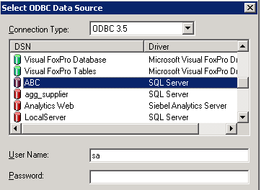
  - In the User Name field, verify that sa is the value and leave the Password field blank.
  - Click OK. The Import dialog box opens.
  - Expand the supplier2 folder.
  - Expand the dbo folder.
  - Select the following tables to import the table schemas into the Physical layer to build ABC’s initial business model:
Note: Click the first table (to deselect any parent objects), and then use CTRL + click to select the remaining tables.
Physical Table Name
D1_Calendar2
D1_customer2
D1_Orders2
D1_products
Note: At import, you can specify the type of metadata to import. The default is to import tables, primary keys, and foreign keys. Only import objects needed for query generation.
  - Verify that the check boxes for Tables, Keys, and Foreign Keys are selected.
  - Verify that ABC, supplier2, and dbo objects are not selected, before you click the Import button.
  - Click Import. The metadata is imported into the Physical layer of the Administration Tool and the data source appears in the Physical layer.
  - When the import is completed, click Close.
  - To display the tables, expand the ABC data source, expand the supplier2 catalog icon, and expand the dbo schema icon.
  - Verify that four tables imported successfully in the dbo folder.
- Verify the connection pool for ABC’s data source.
  - Double-click the Connection Pool object.
  - Modify the connection pool using the following values:
Name | SUPPLIER CP
Data source name | ABC
User name | sa
Password
  - Click OK.
  - Click OK to confirm the blank password.
  - Why would you create more than one Connection Pool for a single data source?
- Perform a visual check to verify that the only key imported automatically into the schema was defined on the D1_Calendar2 table. Expand the folder for each table in the schema looking for the icon next to the columns; this icon indicates that this column is a key column.
  - Click + (plus) to expand D1_Calendar2 table.
  - Observe the YYYYMMDD column.
  - Collapse D1_Calendar2.
  - Expand the D1_customer2 table.
  - Was a key automatically imported for D1_customer2?
  - Collapse D1_customer2.
  - Expand the D1_Orders2 table.
  - Was a key automatically imported for D1_Orders2?
  - Collapse D1_Orders2.
  - Expand the D1_products table.
  - Was a key automatically imported for D1_products?
  - Collapse D1_products.
- Save the repository.
  - Select File > Save.
  - Click No to check Global Consistency.
Note: Check Global Consistency checks for errors in the entire repository. Some of the more common checks are done in the Business Model and Mapping and Presentation layers. Since these layers are not defined yet, bypass this check until the other layers in the repository are built.
- Remain logged in to the Siebel Analytics Administration Tool for the next lab.

Solutions 1-4 Importing a Data Source
Answers
3.c. What column is the primary key constraint defined on?
YYYYMDD
3.d. How many rows are in this table?
474
4.b. Is there a primary key constraint defined on this table?
No
4.c. How many rows are in this table?
136
5.a. Is there a primary key constraint defined on D1_Orders2?
No
5.b. Is there a primary key constraint defined on D1_products?
No
8.e. Why would you create more than one Connection Pool for a single data source?
To give certain users more immediate access to data over other users
9.e. Was a key automatically imported for D1_customer2?
No
9.h. Was a key automatically imported for D1_Orders2?
No
9.k. Was a key automatically imported for D1_products?
No
Lab 1-5 Defining Keys and Joins
Goals | To manually define the primary keys, foreign keys, and joins in the Physical layer using the Siebel Analytics Administration Tool.
Scenario | You have just created a new repository and imported the initial supplier2 table schemas into the Physical layer of the repository. Now, you need to define the primary keys, foreign keys, and joins in the Physical layer manually, because the only key automatically defined was the primary key on D1_Calendar2 table. You will define the keys and join conditions in the other tables used for the business model manually, using the Physical Diagram feature of the Administration Tool.
Outcome | Keys and joins defined on the physical tables.
Time | 15 – 20 minutes
Instructions:
You should still be logged in to the Siebel Analytics Administration Tool.
- Before you begin defining the keys and joins manually, examine the key defined on D1_Calendar2. Double-click the D1_Calendar2 table.
  - Select the Keys tab.
  - Double-click PK_D1_Calendar2 key. The Physical Key dialog box opens.
  - What is the physical key column for this table?
  - How was the key defined automatically for this table?
  - Click Cancel.
  - Select the Foreign Keys tab.
  - Is there a physical foreign key column for this table?
  - Click Cancel.
Note: In the next steps, you will define keys and joins using two techniques. The first technique allows you to create primary keys on tables using the Physical Table properties dialog box. The second technique allows you to create both joins and foreign keys on the table using the Physical Diagram view.
- In the following steps, you will use the first technique—using the Physical Tables properties—to configure the primary key on the D1_Orders2 table. The primary key for D1_Orders2 is made up of multiple columns, called a compound key (ProdKey, PeriodKey, and CustKey) used to uniquely identify a row in a table.
  - In the Physical layer, double-click the D1_Orders2 table.
  - Select the Keys tab.
  - Click New. The Physical Key dialog box opens.
  - Select the check boxes for the following columns:
Column Name
ProdKey
PeriodKey
CustKey

  - Click OK to close the Physical Key dialog box.
Note: Even though you have selected three columns, only one will appear in this dialog box.
  - Click OK to close the Physical Table window.
- Verify that the three columns (CustKey, PeriodKey, and ProdKey) display the Primary Key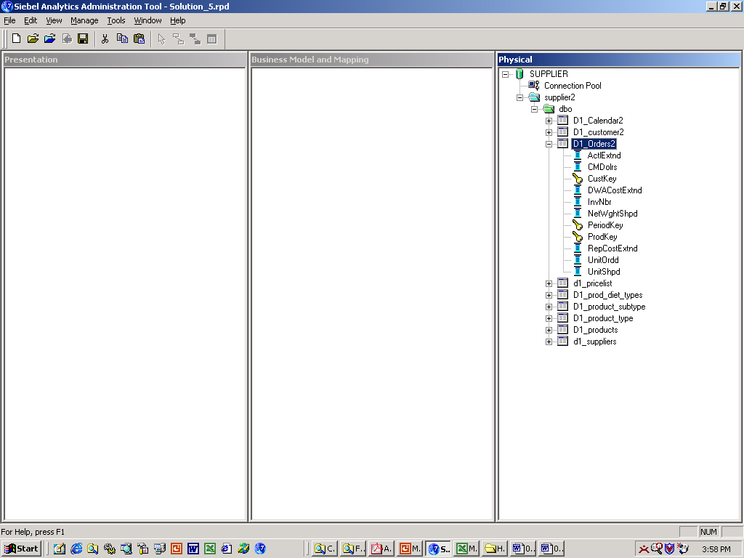 icon in the Physical layer.
Note: You may have noticed that the Primary Key icons appear only in the Physical layer. They did not appear in the Physical table dialog box in a prior step.
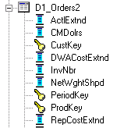
  - Collapse the D1_Orders2 table.
- Using the second technique in the following steps, you will define joins and foreign keys using the Physical Diagram view.
  - Right-click the ABC data source and select Physical Diagram > [any option] to open the Physical Diagram view.
  - Drag the table objects so they are all visible.
  - The first join you will create will define the relationship between D1_Calendar2 and D1_Orders2. The join you create will represent the following relationship between these tables: D1_Calendar2 has a one-to-many relationship with D1_Orders2.
    - Click the New Foreign Key button on the toolbar.
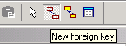
    - Click the D1_Calendar2 table, and then click the D1_Orders2 table.
Note: It matters which table you click first. The join is creating a one-to-many (1:N) relationship that joins the primary key column in the first table to a column that is a foreign key in the second table.
    - Select the columns that join the tables. Select the D1_Calendar2.YYYYMMDD column, and then select the D1_Orders2.PeriodKey. Verify that the Expression edit box (bottom) contains the following expression:
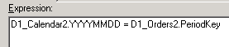
    - Click OK.
    - Observe the 1:N relationship between D1_Calendar2 and D1_Orders2 represented in the Physical Diagram view:
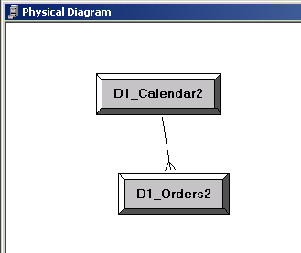
- Repeat the process you just completed and create joins and foreign keys for the other tables.
Note: As you create the joins, a message will appear, asking you to create a column as a ‘key column’ on the first table, which is necessary to create the relationship to the foreign key column in the second table. When you see this message, click Yes.
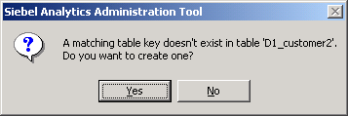
  - Create the joins based on the expressions listed below. The join is creating a one-to-many (1:N) relationship that joins the key column in the first table to a column that is a foreign key in the second table.
Note: Verify that each Expression edit box contains the following expression:
D1_customer2.NewKey = D1_Orders2.CustKey
D1_products.ProductKey = D1_Orders2.ProdKey
  - Observe the Physical Diagram:
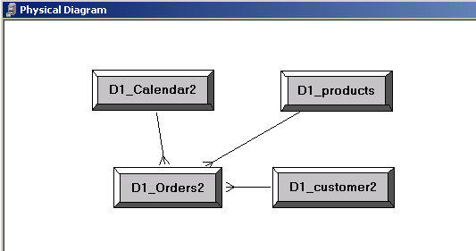
  - Close the Physical Diagram window.
- Observe some additional options for viewing the physical table diagram. Right-click D1_Calendar2 table and select Physical Diagram > Object(s) and Direct Joins.
  - Observe the Physical Diagram:
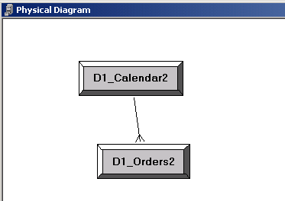
  - Close the Physical Diagram window.
  - Repeat this process for D1_Orders2 table, by selecting Physical Diagram > Object(s) and Direct Joins for D1_Orders2 table. Why are ALL of the tables visible in the diagram with D1_Orders2?
  - Close the Physical Diagram window.
- Select File > Exit to exit the Siebel Analytics Administration Tool.
- Click Yes to save changes.
Solutions 1-5 Defining Keys and Joins
Answers
1.c. What is the physical key column for this table?
YYYYMMDD
1.d. How was the key automatically defined for this table?
The key was defined in the source database (supplier2) as a primary-key constraint, created automatically during the import schema process. Note: The metadata-type Tables, Keys, and Foreign Keys were enabled during the import process.
1.g. Is there a physical foreign key column for this table?
No
7.c. Why are ALL of the tables visible in the diagram with D1_Orders2?
All of the tables have a one-to-many relationship with D1_Orders2.

